TIPSY

2019



CSE 308

Team Maroon

Front-End Documentation

Logo



This is the logo of Tipsy. The “Y” is represented as a cocktail cup, which shows the topic of this web app.

Color Theme

Primary Color: #444444 (light gray)

Secondary Color1: #008080(Teal)

Secondary Color2: #800000 (Maroon)

Secondary Color3: #FFFFFF(White)

Secondary Color4: #1C1C1C (dark gray)

* Bg → light gray
* Grid card → teal
* Buttons → maroon with white words
* form prompt → grey
* Other words → white
* Tab bg → dark gray

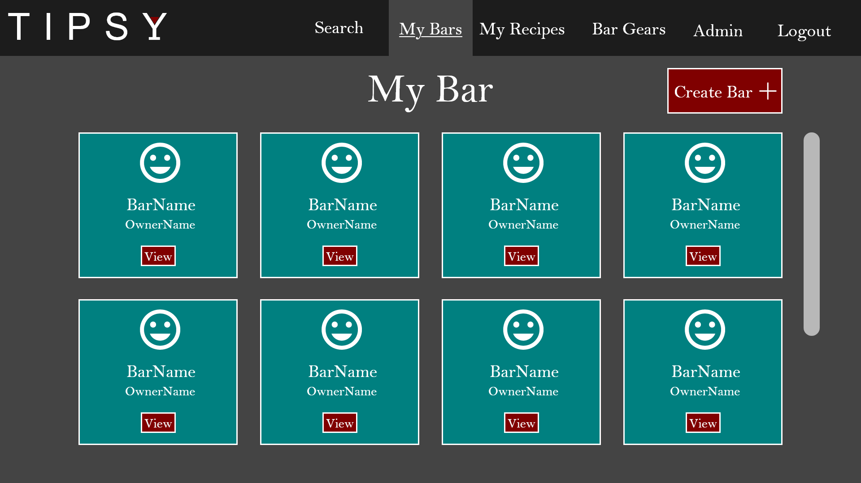

Typography

Website Fonts: Roboto Mono

ABCČĆDĐEFGHIJKLMNOPQRSŠTUVWXYZŽ

abcčćdđefghijklmnopqrsštuvwxyzž

Assets



